Digital Design

CSCE 2114-L007

Blake Fasse

September 20, 2016

[bafasse@uark.edu](mailto:bafasse@uark.edu)

The purpose of this lab was to understand of basics of how to use Quartus and the FPGA board. Using Quartus on the computer we made a circuit using a NOR gate and then sent it to the FPGA board where it was programmed to act like a NOR gate. Once the board was programmed it acted exactly as if a NOR gate had physically been built on the bread board. Anytime the button was pushed it sent a 0 and when the button wasn’t pushed it sent a 1 and only when both buttons were pressed it the LED on the board change.

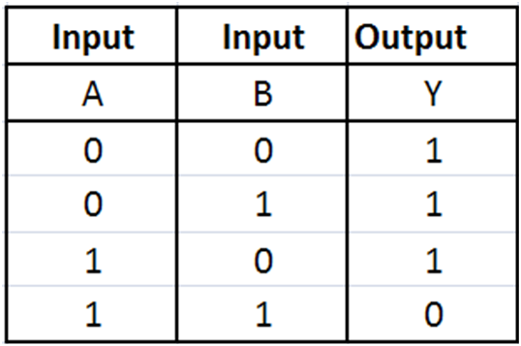 NOR gates are OR gates that have inverters on them so the output can only be a 0 when both inputs are a 1 and any other combination of inputs would give an output of 1. Physically they are two IC’s, the 7432 and the 7404, that have been wired together. Seeing how simple they are to build physically, using Quartus just made it even more simple. All that needed to be done was put the NOR gate on the board, place two inputs and one output, connect everything and then push the program to the FPGA board. The results that were expected are shown in the picture below and sure enough those were the results that were achieved.

Truth Table for a NOR gate

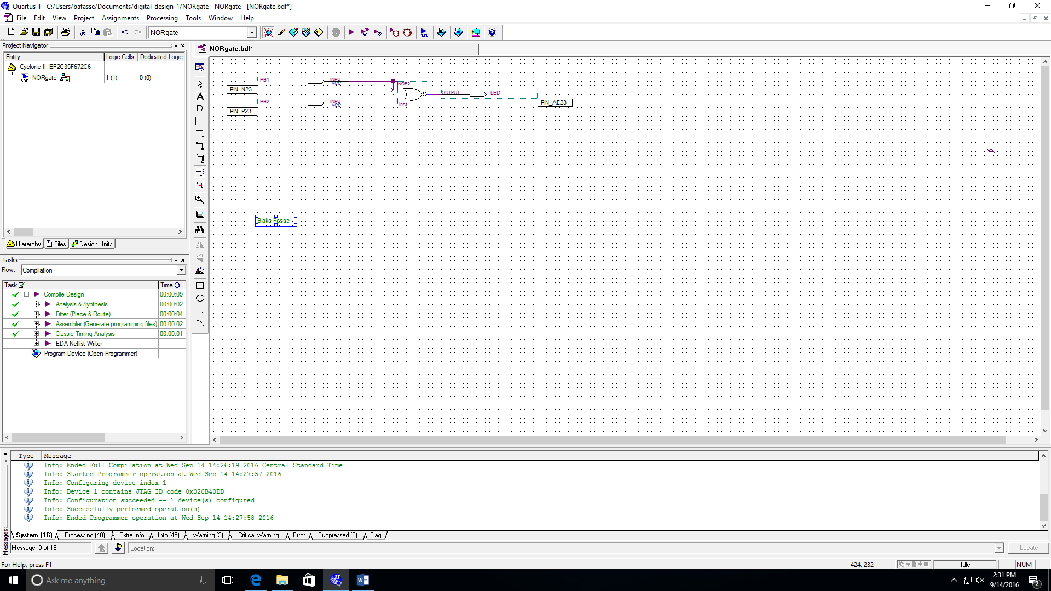

As stated before the result that were achieved are show in the truth table above. Only when both inputs are a 1 can the output be a 0 and every other input resulted in an output of 1. Above is a picture of how the NOR gate was built on Quartus. The only problem that was encountered was when the pin that was supposed to be assigned to PIN_AE23 was accidently assigned to PIN_A23 instead. This lab was able to be completed in roughly 30-45 minutes.

Using Quartus to create logic devices, we used it to create a NOR gate that would programmed to the FPGA board in order to simulate a NOR gate that was built on a bread board. This was a very simple lab with no real problems. It was nice figuring out how to use Quartus and the FPGA board.